* User
  + Name
  + Email
  + Password
  + Properties IDs
  + isAdmin
* Property
  + ID
  + Name
  + Address
  + Description
  + Price
  + Housing Type
  + Amenities
  + Approval
* Landing Page Example A screenshot of a computer

  Description automatically generated
* Search Results Example 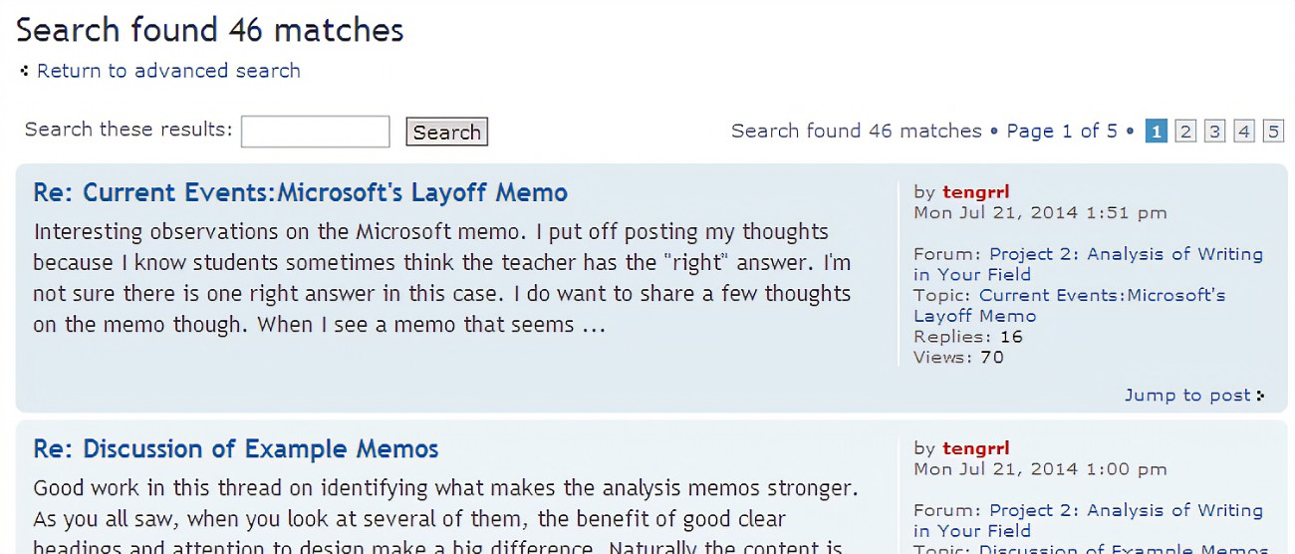
* Property Page Example A screenshot of a computer

  Description automatically generated